### 3.1.18 Create Promotion

|  |  |
| --- | --- |
| Description | Manager create new promotion for restaurant |
| Actor | Manager |
| Pre-condition | Manager login to system, access to Promotion Feature, and press on button Add |
| Post-condition | New promotion will be created |
| Data Table | Promotion |
| Usage Frequency | Often | Regular | Low |
| Criticality | High | Normal | Low |
| Denpendencies | N/A |

**Activity Flow**

|  |  |
| --- | --- |
| Actor | System |
| 1. Manager access to application |  |
| 2. Manager access to Promotion Feature | 3. System display Promotion Screen |
| 4. Manager press on button “Add” | 5. System display Add New Promotion Dialog |
| 6. Manager input all require fields |  |
| 7. Manager press on button “Save” | 10. System save new promotion to database |
|  | 11. System show dialog to notify successfully |

**Alternative Flow**

* Not input all require field: system will notify manager “Vui lòng nhập các trường bắt buộc”.
* Invalid input: system will notify manager with each field have invalid input.
* Manager press on button “Hủy”: promotion will not be save.

**Bussiness Rules**

|  |  |
| --- | --- |
| BR ID | Description |
| BR 1 | If manager have not input all required fields, system will show error |
| BR 2 | If have invalid field, system will show error below that field. |
| BR 3 | Focus into firt field when open modal |
| BR 4 | Start day must smaller than or = end date, and Start day must set min default = today. |

**Wireframes**

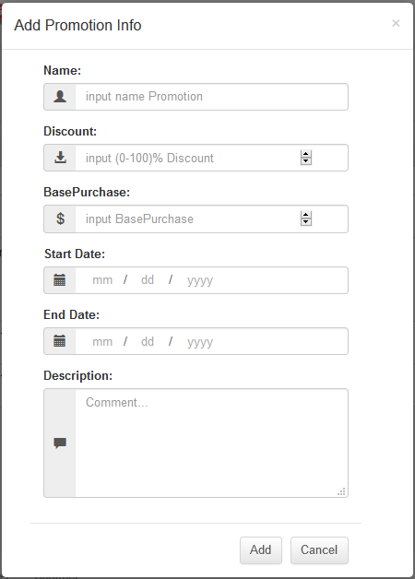

Wireframes 3.1.18.1 Create Promotion

**Wireframes Description**

|  |  |  |  |
| --- | --- | --- | --- |
| No | Control Name | Control Type | Description |
|  | | | |
| 1 | “Name” Label | Label |  |
| 2 | Promotion name | Textbox |  |
| 3 | “Start Date” Label | Label |  |
| 4 | Start date | Textbox |  |
| 5 | “End Date” Label | Label |  |
| 6 | End date | Textbox |  |
| 7 | “Discount” Label | Label |  |
| 8 | Discount | Number |  |
| 9 | “BasePurchase” Label | Label |  |
| 10 | BasePurchase | Number |  |
| 11 | “Start Date” Label | Label |  |
| 12 | Start date | Datetime |  |
| 13 | “End Date” Label | Label |  |
| 14 | End date | Datetime |  |
| 15 | “Description” Label | Label |  |
| 16 | Description | Textbox |  |
| 17 | “Add” button | Button |  |
| 18 | “Cancel” button | Button |  |

### 3.1.19 Search Promotion

|  |  |
| --- | --- |
| Description | Manager search for promotion in system |
| Actor | Manager |
| Pre-condition | Manager log in to system, access to Promotion Feature |
| Post-condition | System show promotion to list promotion view |
| Data Table | Promotion |
| Usage Frequency | Often | Regular | Low |
| Criticality | High | Normal | Low |
| Denpendencies | N/A |

**Activity Flow**

|  |  |
| --- | --- |
| Actor | System |
| 1. Manager access to application |  |
| 2. Manager access to Promotion Feature | 3. System display Promotion Screen |
| 4. Manager input to filter fields (not require) |  |
| 5. Manager press on button “Search” | 6. System search on database by filter fields |
|  | 7. System show promotions on list view |

**Alternative Flow**

* Not found promotion: System will show message under header of the list view.

**Bussiness Rules**

**Wireframes**

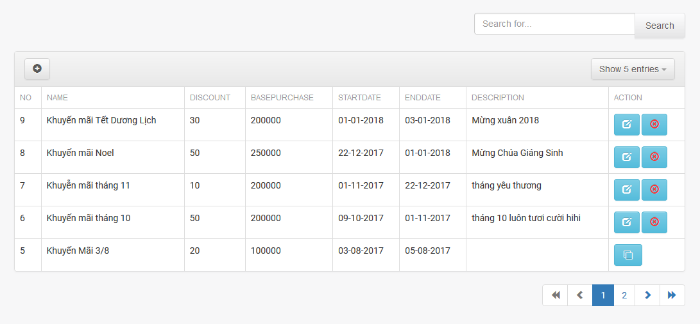

**Wireframes Description**

|  |  |  |  |
| --- | --- | --- | --- |
| No | Control Name | Control Type | Description |
|  | | | |
| 6 | “Search for” | Textbox |  |
| 7 | “Search” button | Button |  |
| 9 | “Add” Icon | Button |  |
|  | “Show entries” | ComboBox |  |
|  | Promotion table | Table |  |

### 3.1.20 Update Promotion

|  |  |
| --- | --- |
| Description | Manager want to update detail of promotion |
| Actor | Manager |
| Pre-condition | Manager login to system, access to Promotion Feature, and press on icon edit beside promotion information in table |
| Post-condition | Promotion details will be updated |
| Data Table | Promotion |
| Usage Frequency | Often | Regular | Low |
| Criticality | High | Normal | Low |
| Denpendencies | N/A |

**Activity Flow**

|  |  |
| --- | --- |
| Actor | System |
| 1. Manager press icon edit beside promotion item in product list | 2. System display dialog Update Promotion Information |
| 3. Manager input fields |  |
| 4. Manager press icon edit beside a product in promotion details | 5. System display dialog Update Promotion detail |
| 6. Manager press on button “Update” | 7. System update promotion information to database |
|  | 8. System show notification that promotion successfully updated |

**Alternative Flow**

* Not input all require field: system will notify manager “Vui lòng nhập các trường bắt buộc”.
* Invalid input: system will notify manager with each field have invalid input.

**Bussiness Rules**

|  |  |
| --- | --- |
| BR ID | Description |
| BR 1 | If manager have not input all required fields, system will show error |
| BR 2 | If have invalid field, system will show error below that field. |

**Wireframes**

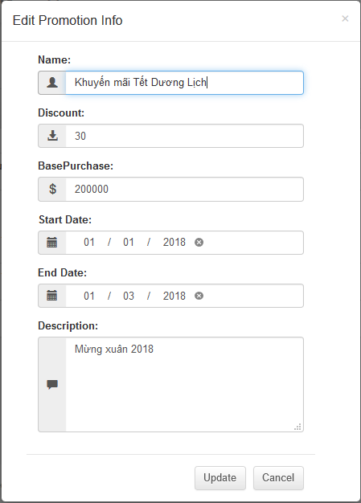

Wireframes 3.1.20.1 Update Promotion

**Wireframes Description**

|  |  |  |  |
| --- | --- | --- | --- |
| No | Control Name | Control Type | Description |
|  | | | |
| 1 | “Name” Label | Label |  |
| 2 | Promotion name | Textbox |  |
| 3 | “Start Date” Label | Label |  |
| 4 | Start date | Textbox |  |
| 5 | “End Date” Label | Label |  |
| 6 | End date | Textbox |  |
| 7 | “Discount” Label | Label |  |
| 8 | Discount | Number |  |
| 9 | “BasePurchase” Label | Label |  |
| 10 | BasePurchase | Number |  |
| 11 | “Start Date” Label | Label |  |
| 12 | Start date | Datetime |  |
| 13 | “End Date” Label | Label |  |
| 14 | End date | Datetime |  |
| 15 | “Description” Label | Label |  |
| 16 | Description | Textbox |  |
| 17 | “Update” button | Button |  |
| 18 | “Cancel” button | Button |  |

### 3.1.21 Delete Promotion

|  |  |
| --- | --- |
| Description | Manager want to delete a promotion from their menu |
| Actor | Manager |
| Pre-condition | Manager login to system, access to Promotion Feature. search promotion and click on button “Delete” beside product item in product list |
| Post-condition | Product is deleted from system |
| Data Table | Product |
| Usage Frequency | Often | Regular | Low |
| Criticality | High | Normal | Low |
| Denpendencies | N/A |

**Activity Flow**

|  |  |
| --- | --- |
| Actor | System |
| 1. Manager press on button “Delete” beside product item | 2. System show dialog to confirm delete product |
| 3. Manager press on button “Ok” | 4. System delete product |
|  | 5. System notify product successfully deleded |

**Alternative Flow**

* Manager press on Button “Cancel”: System will not delete product.

**Bussiness Rules**

**Wireframes**

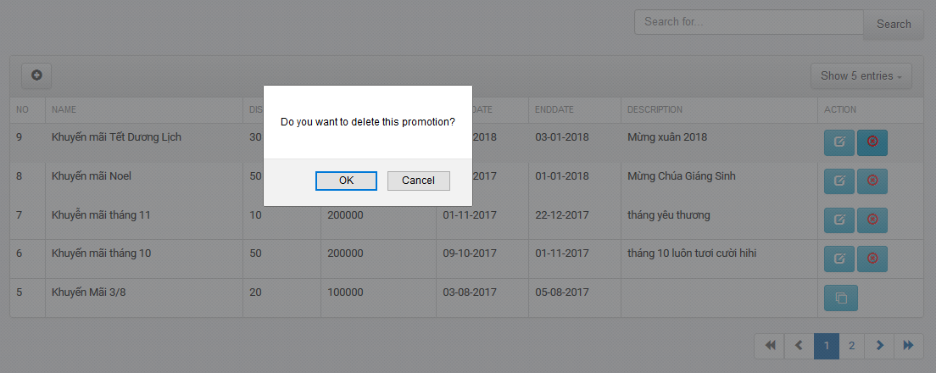

Wireframes 3.1.9 Delete Promotion

**Wireframes Description**

|  |  |  |  |
| --- | --- | --- | --- |
| No | Control Name | Control Type | Description |
|  | | | |
| 1 | “Ok” button | Button |  |
| 2 | “Cancel” button | Button |  |